Tim Livingston

OPS 811

WWE Grapples with Its Growth Potential

**Company History**

World Wrestling Entertainment (WWE) is a sports entertainment company that evolved from a regional professional wrestling organization into the genre’s largest purveyor in history. It was started in 1952 by Jess McMahon as the Capitol Wrestling Corporation (CWC) and was a part of a nationwide conglomerate of wrestling companies called the National Wrestling Alliance (NWA). After a disagreement with the NWA in 1963, it split off and formed their own entity, the World Wide Wrestling Federation (WWWF). Performing mainly in New England and into Canada, it rose in popularity and was renamed to the World Wrestling Federation (WWF) in 1979. Jess eventually sold the company to his youngest son, Vincent Kennedy, in 1982.

It was here when the company began its rise to worldwide prominence. Aggressively, McMahon went out and got the best talent in the United States that wasn’t associated with the NWA and began crafting a company built around entertainment more than athleticism. With stars like Hulk Hogan, “Rowdy” Roddy Piper, and “Macho Man” Randy Savage headlining shows, along with partnerships with NBC Sports and MTV, WWF soon became a household name not just amongst sports fans, but those in the entertainment world, too. The arrival of the “Attitude Era” in the mid-to-late 1990’s, spawned by the ascension of talents like “Stone Cold” Steve Austin and Dwayne “The Rock” Johnson gave the company a boost to blow past its competition, resulting in the company’s initial public offering in October 1999.

**Growth**

Due to its unique standing as an entertainment company that rivals live sporting events, movies, concerts, and television, WWE’s growth has been tough to pin down. Beginning with its IPO, WWE had a stock price at $24.13 with a valuation of $172.5M. Today, its valuation is nearly 10 times that with a $1.52B market cap, but with a stock price at $20.03 as of May 30. The fluctuations mainly had to do with revenue channels, as the company had the majority of its revenue model based around broadcast rights, live event ticket sales, and pay-per-view revenues.

For 2016, WWE accrued $729.2M revenue from five major sources: Media Division ($462.6M), Live Events ($144.4M), Consumer Products ($107.9M), WWE Studios ($10.1M), and Corporate & Other ($4.2M). The Media Division revenue stream was announced in 2014 as a combination of its WWE Network over-the-top subscription service and both live and television entertainment services. In 2016, Media Division accounted for nearly two-thirds of the company’s revenue (63.4%), slightly down from 64.6% in 2015.

With an SIC code of 7812, this puts WWE in the same category as other major players in Motion Picture and Video Tape Production. Its valuation is paltry next to companies like Sony Pictures ($46.27B) or Warner Brothers ($76.5B). Private companies such as LucasFilm and Pixar also fall into this index and are both owned by Disney, who bought LucasFilm for $4B in 2012 and Pixar for $7.4B in 2006. However, it has turned over a profit thanks to the WWE Network. While it had a 15.5% Operating Income Before Depreciation and Amortization (OIBDA) loss in 2014 when it started the service, the company had a huge bounce back up to 61.6% in 2015 and 80.1% in 2016. It took a chance in going to a model with the WWE Network at its forefront, but the investment has paid off.

**OIBDA**

Since moving to a traditional corporate reporting calendar in 2011, WWE has used OIBDA as its main profit KPI. In 2010, they hit an all-time high OIBDA of $94M. In 2011, the company began construction of the WWE Network and scaled back operating costs and expenses to run their shows, with OIBDA falling to $52M in 2011. After a slight bounce back to $63.2M in 2012, final preparations for the Network saw the number fall to $30.4M in 2013. After the -$15.5M number in 2014, the Network gained traction and saw an incredible jump to $61.6M in 2015 and rose even further in 2016 to $80.1M, the fourth highest annual mark since 2006.

The margin between OIBDA and the company’s operating income has remained steady throughout the years, staying between 11% and 20% for a majority of the last 10 years. It only dipped below that number in 2013-2015.

**The WWE Network**

In February 2014, after four years of development, the WWE Network was unveiled as an alternative to the pay-per-view and cable services that had propped up its business model for over two decades. Built on the Major League Baseball Advanced Media (MLBAM) streaming video infrastructure, WWE can deliver original programming and live specials to its audience, deciding to move its famous pay-per-view shows like WrestleMania, the Royal Rumble, SummerSlam, and Survivor Series into this service. With many consumers using products other than traditional cable outlets for entertainment such as Roku and Apple TV, and with similar OTT services from Netflix, Hulu, and even HBO, WWE saw an opportunity in the market to widen its audience and was one of the first content providers to market. Subscribers to the monthly service pay $9.99 and get access to an extensive video library of every major past event for WWE and the competitors it bought out over the past three-plus decades, along with exclusive specials to help cultivate Network offerings for both the casual and hardcore fan. It is available on every major streaming device on the market, most notably Apple TV, Roku, Amazon Fire, PlayStation, and Xbox.

With a goal of 1 million subscribers in its first year, WWE hit 816K in 2014, only to see a large increase up to 1.2M in 2015 and 1.4M in 2016. They did differ in regard to paid subscribers versus those trying out the platform for 30 days on a trial basis, but after having only 567K paid subscribers in 2014 and 1.1M in 2015, the average number was actually higher than the total numbers of subscribers in 2016, at 1.42M compared to 1.4M. This allowed them to make their brand more international as opposed to relying on television rights deals for revenue, as will be explained in the next section.

For live events, for which the WWE Network is the main revenue driver, North American attendance has remained steady even after the debut of the Network (between 5800 and 6000 for each of the past six years), but has risen sharply internationally, growing from 6200 attendees per event in 2014 to 7500 in 2016, its largest mark since 2010. Previously stagnant revenues in live events went up during this time, as well, going from an average of $107M in the five years before the Network to an average of $126.5M in the three years since, topping out at $144M in 2016. WWE had scaled back international events before the release of the WWE Network to help with the cost of the operation, but ramped up again once the Network was well received.

The Network is now available in over 170 countries per the company’s official website, and remains the only live sports product based in the United States that can be purchased on its own without local cable blackout restrictions. During the company’s most recent conference call after Q1 2017, it was revealed the subscriber total was 1.949M, just shy of the company’s internal goal of 2M it had hoped to get before WrestleMania 33 this past April.

**Total Revenues**

After some stagnant revenues in the late 2000s and early 2010s, WWE finally experienced some upward mobility beginning in 2013. It was the final year of their contract with NBC Universal for the domestic rights to its flagship television shows: *Monday Night Raw* and *SmackDown! Live*. The hope was that they could double or even triple their previous contract thanks to the launch of the WWE Network. However, they were only able to increase the totality of the deal slightly in their multi-year deal, hurting their overall revenue mark. The television rights agreed to by NBC Universal are only about $150M annually, up from $90M from the previous deal. The three previous years saw $132.6M, $140.9M, and $163.4M marks for worldwide TV rights, but 2014 saw that number climb only to $176.7M. There were jumps in 2015 and 2016 to $231.1M and $242M thanks mainly to various worldwide television rights. When the new TV deal was announced, WWE stock dropped 45% to $11.32 a share due to analyst expectations based on the company’s perceived value of their television rights.

However, along with the aforementioned live event sales, the WWE Network revenue has been a boon to the company, bringing in $115M in revenue in 2014 and jumping sharply up to $159.4M in 2015, helping recoup a little bit of the loss from the missed TV deal. 2016 saw the annual number at $181M, surpassing the worldwide television revenue from 2014. It remains about 75% of the worldwide television revenue total right now, but could close that gap with a continued strong worldwide push.

**Road Ahead**

It seems that the WWE is at a crossroads in regard to how they see their revenue model going forward. Television rights accounted for 33% of the company’s total revenue in 2016, and is still the company’s leading revenue generator. While they have two more years left on their current deal with NBC Universal, the growing sentiment around cord cutting and tumbling cable ratings might leave them without a home come 2019, or at the very least, with another deal that could leave them short of what they think the brand would be worth. The WWE Network is growing, but will they be able to make enough money with the Network where television rights are either secondary or not needed at all? If the answer is yes, a re-investment into the Network and live events, the company’s third leading revenue generator, will be the key goal over the next three years.

The focus also seems to be shifting from a domestic approach to a worldwide approach. WWE looks to both China and India as opportunities to increase Network viewing, and their recent crowning of Jinder Mahal as the first wrestler of Indian descent to be the company’s champion has been well-received in India. Financially, they are expecting 2017 to shatter their previous OIBDA record from 2012, projecting $100M by year’s end.

**Recommendation and Conclusions**

For a niche company like WWE, they walk a tightrope with their standing in the entertainment industry. Having been built around a television model that kept them upright for decades, the ability to move into the over-the-top environment at the forefront of the technology gave them a competitive advantage over others that might have taken a bit longer to adjust to. However, in the nearly two decades that the company has gone public, their stock price has remained basically still even as their market cap has increased 10-fold. Even the bump of the company’s stock up to the all-time high of $28.88 on March 1, 2014, a week after the WWE Network debut, has fallen off precipitously, and now the company must bank on their foreign development over domestic development going forward.

Over the last four quarters, the WWE has missed on its earnings estimates, but the company’s ability to market internationally and take advantage of non-traditional marketing outlets, such as social media and YouTube, has made their company imprint substantial. Finding a way to monetize that imprint can also help in a future were the television landscape is murky in the near future.

Stock analysts right now based upon Yahoo! Finance and Google Finance information range between a hold on purchasing WWE stock and a slight buy. This falls in line with information that while the recent worldwide growth is good, the rate at which it’s increasing may not please many potential buyers. With their biggest event of the corporate year over with, company expenses will decrease going forward, giving them an opportunity to see revenue growth. If the subscription total reaches 2 million people and the company stays on track with expected revenue and OIBDA results after the Q2 earnings call in July, it would be worth a purchase. I’m leaning towards a slight buy right now due to optimism with worldwide growth, with a chance to purchase more upon good news from the Q2 earnings call.

**Reference:**

DiPietro, Frank. “Wrestlemania 33 Breaks Records -- What Investors Need to Know. ” *The Motley Fool.* Web. 30 May 2017.

“WWE® Reports First Quarter 2017 Results.” **–** *WWE Business Wire.* Web. 04 May 2017

Flint, Joe. “WWE stock gets smacked down after new TV deals are unveiled.” *Los Angeles Times.* Web. 16 May 2014.

Zacks Equity Research. “World Wrestling (WWE) Echoes Q4 OBIDA Outlook, Stock Down.” *Nasdaq*. Web. 13 Dec 2016.

“Yahoo! Finance Summary – WWE.” *Yahoo! Finance*. Web. 30 May 2017

“Google Finance Summary – WWE.” *Google Finance*. Web. 30 May 2017

Howard, Brandon. “WWE Master Training Schedules. (Spreadsheet)” *Voices of Wrestling.* Web. 30 May 2017.

Harrington, Chris. “Annual WWE Financials 1998-2015. (Spreadsheet)” *Wrestlenomics.* Web. 30 May 2017.

**Appendix:**

***A. Annual Revenues From 2006-2016***

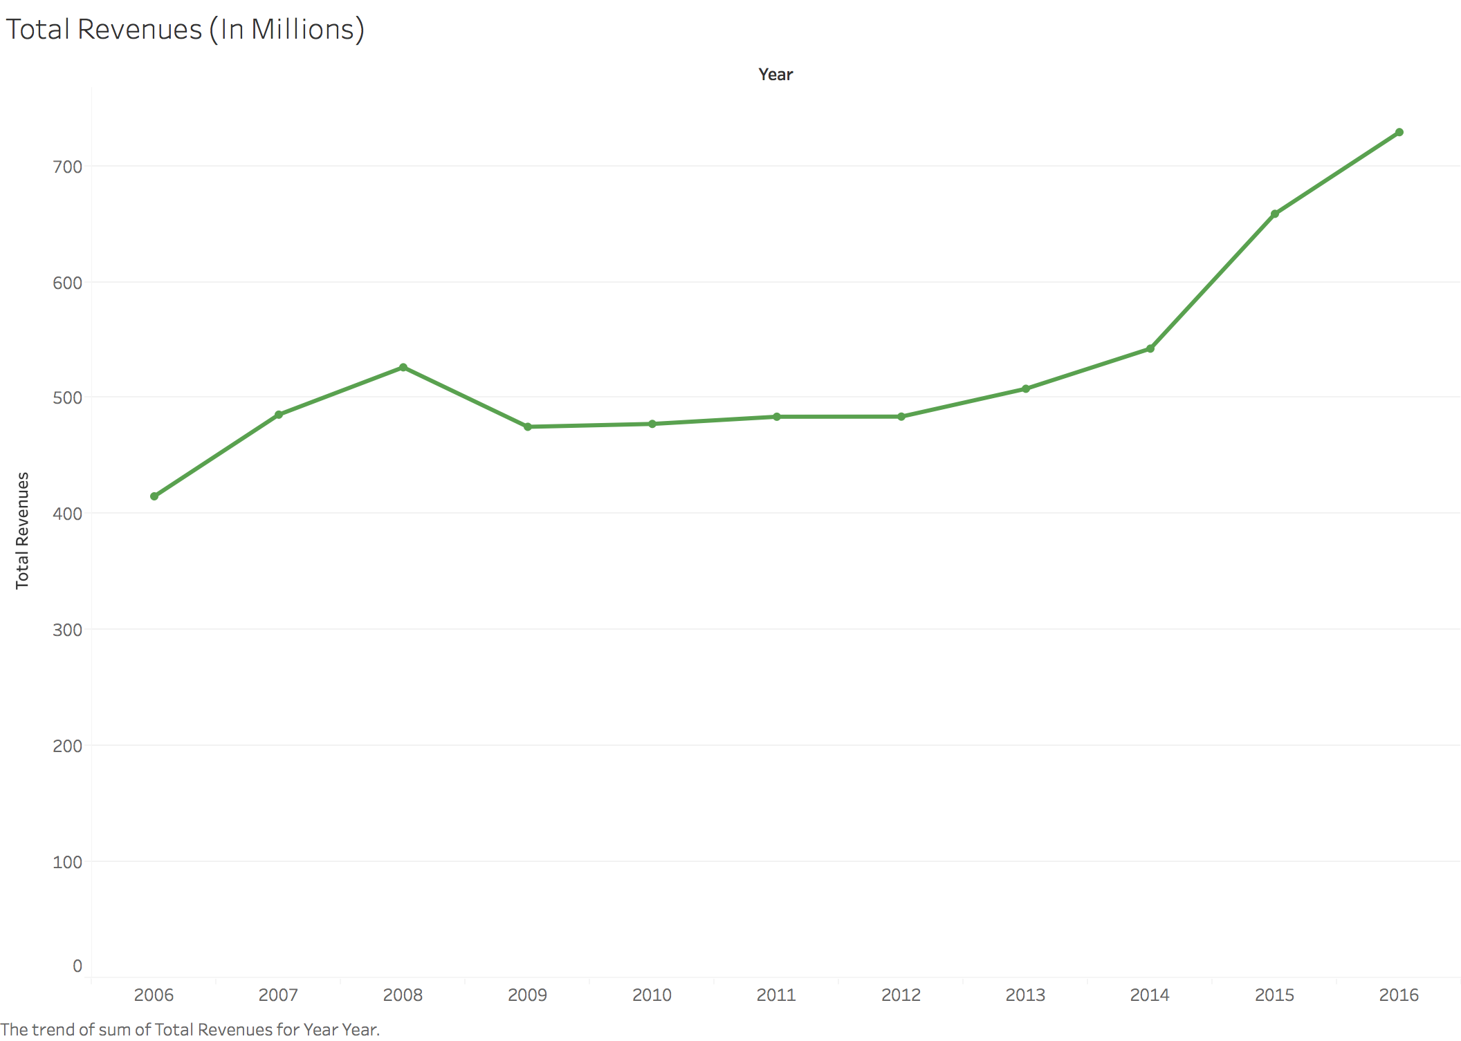

***B. Revenue Breakdown Post-WWE Network Debut***

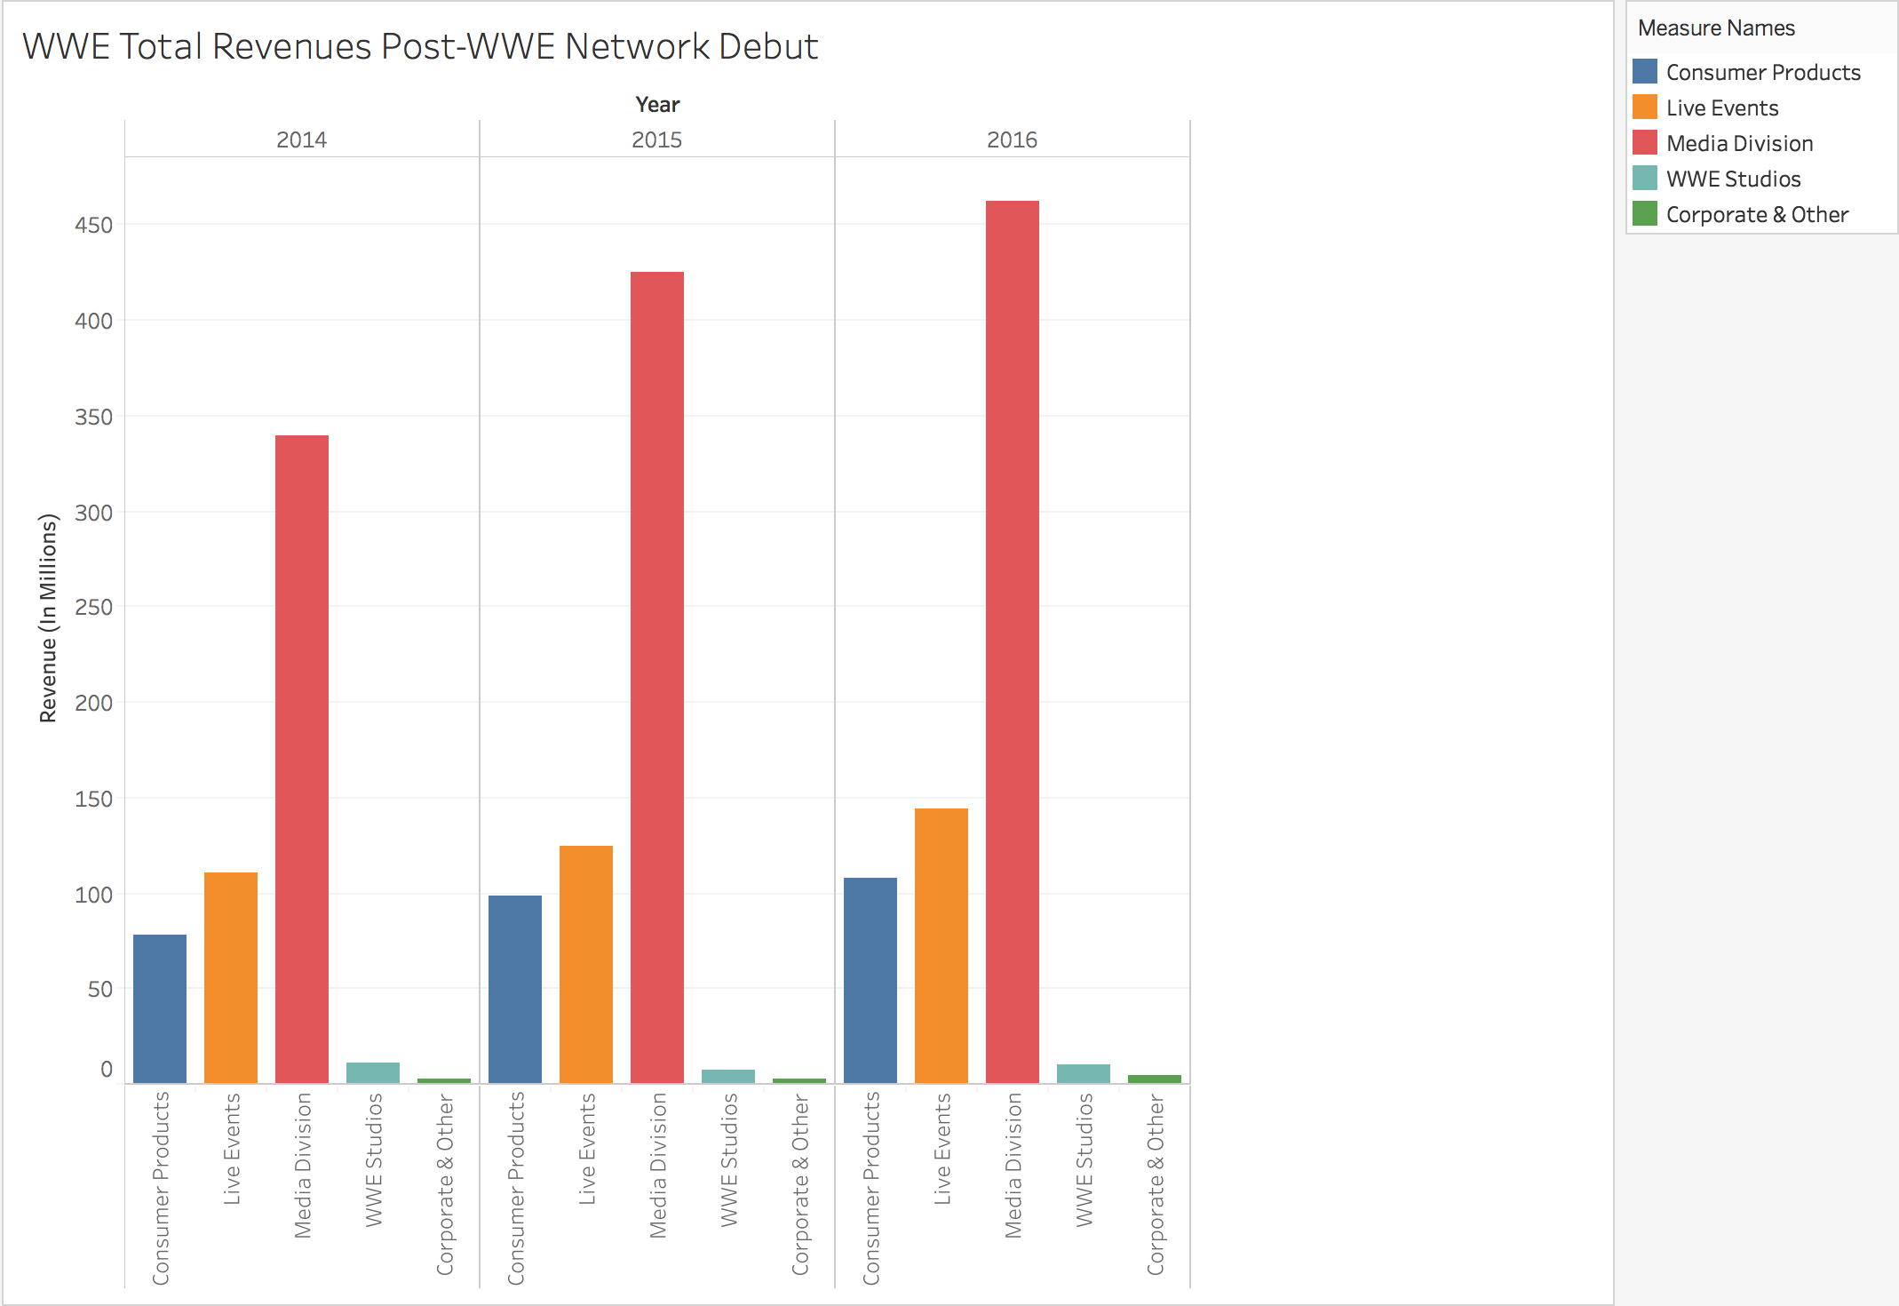

***C. Growth Trajectory of WWE Network compared to Television Rights***

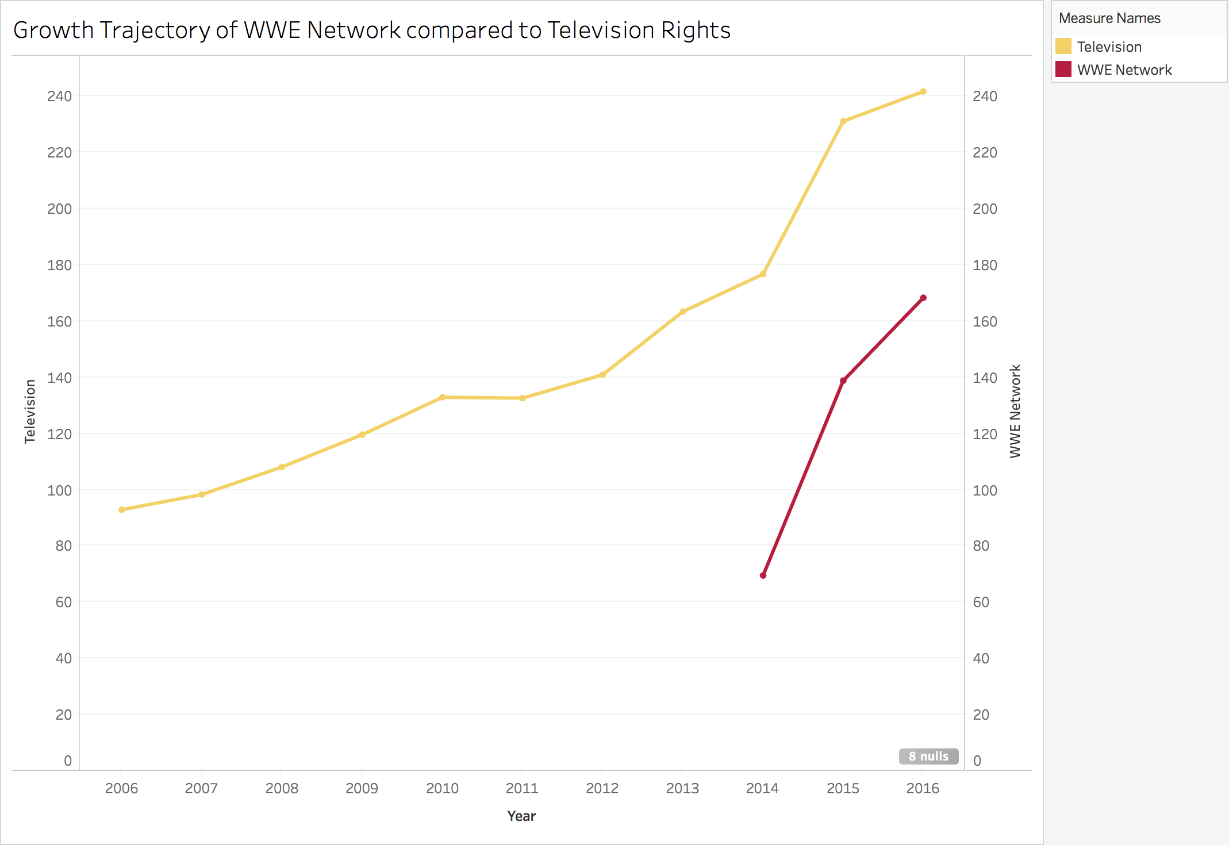

***D. Paid Subscriber Growth of WWE Network***

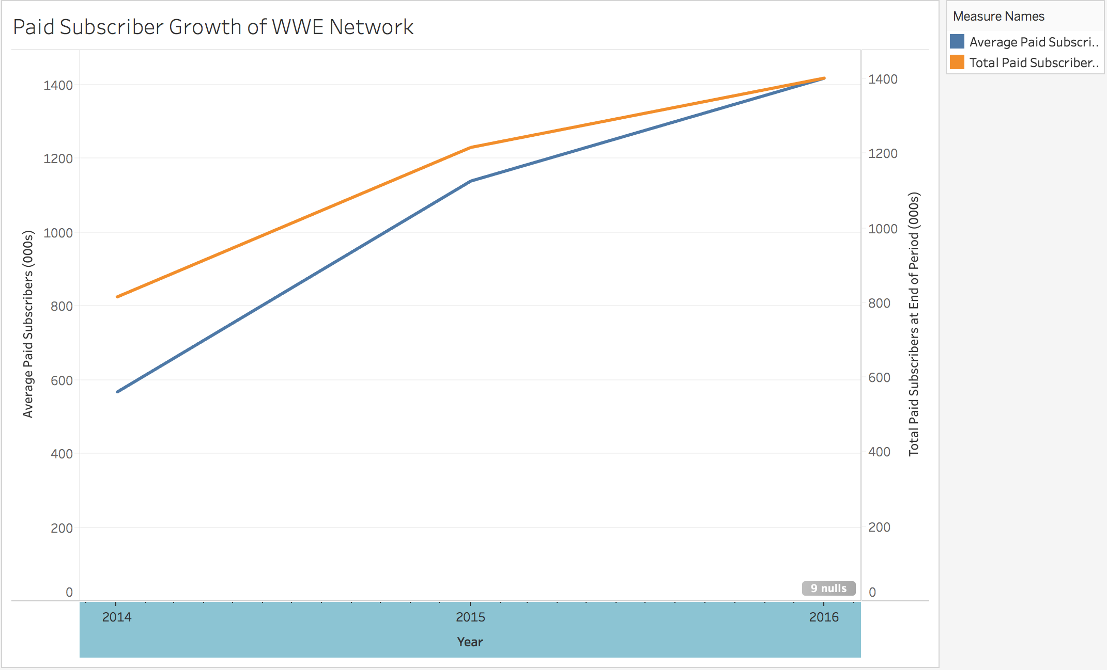

***E. Average Attendance: North America vs. International***

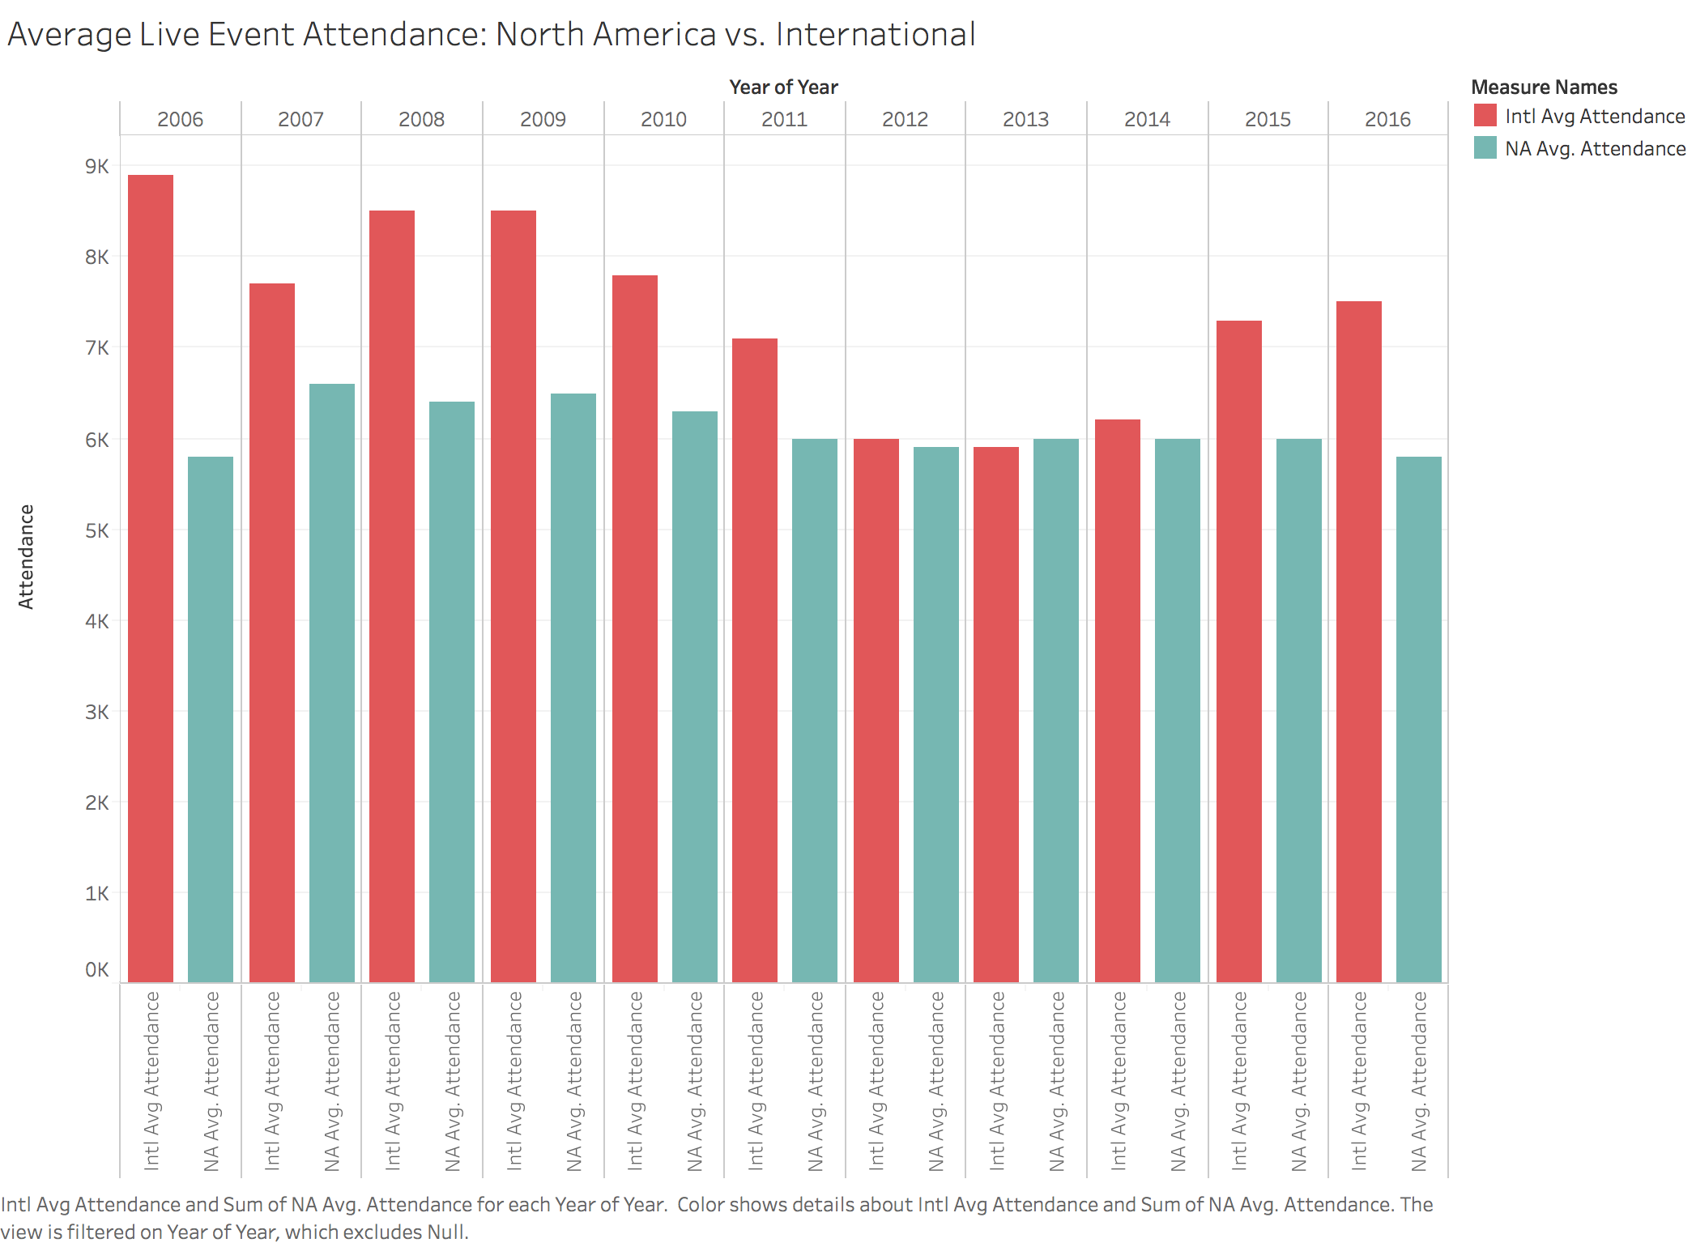

***F. Television Ratings: Monday Night Raw vs. SmackDown! Live***

***.*** 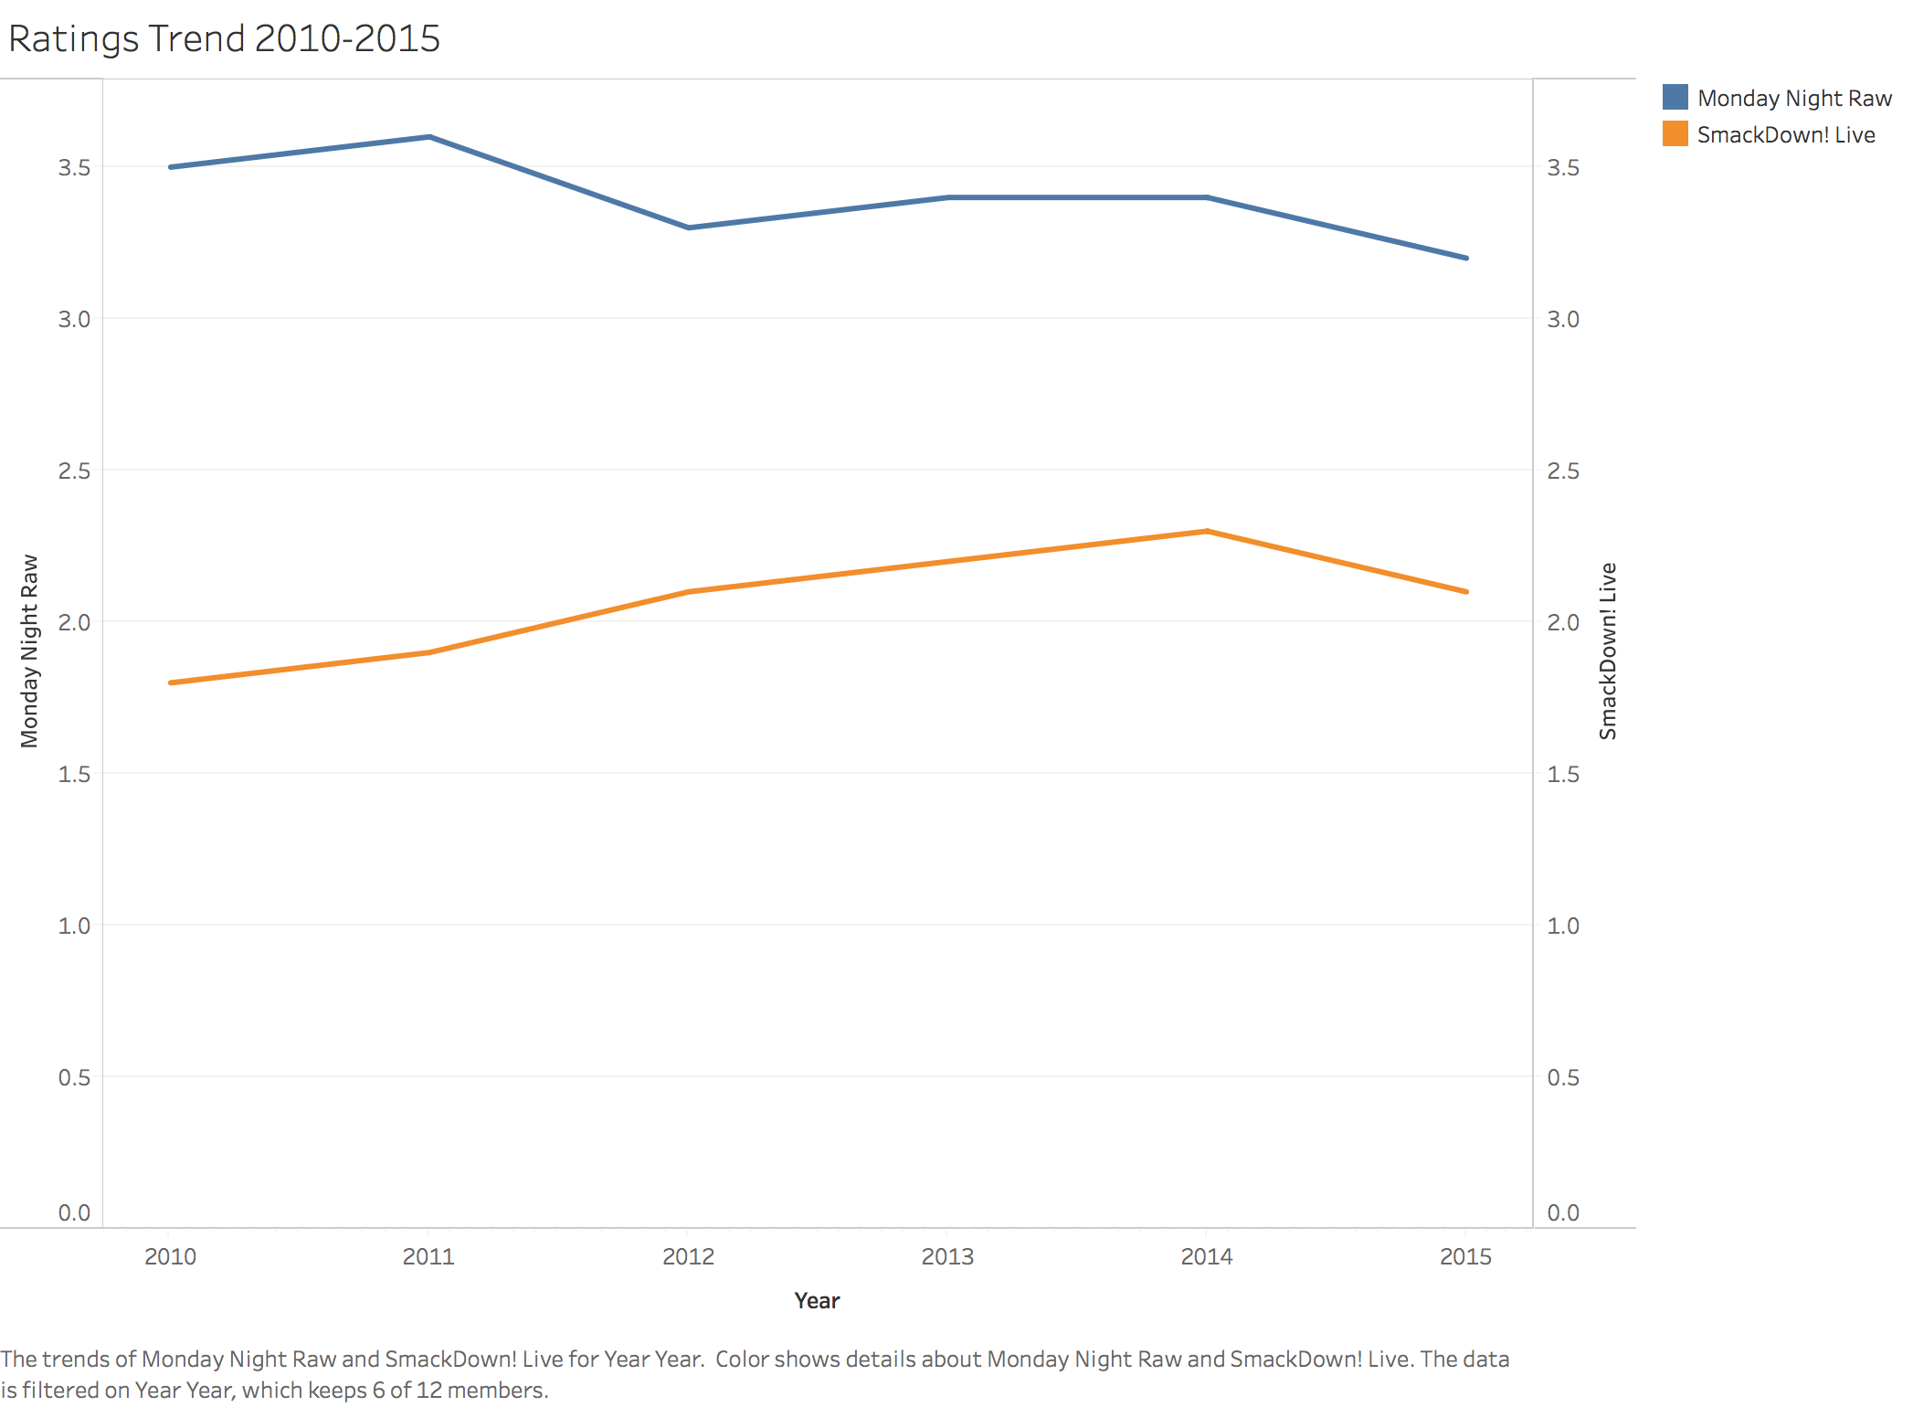

***G. OIBDA Comparison to Operating Income***

